Protocol for using Genomic DB Browser
Xiaopei Update @ 11.20.2025
Contents
A. Auto Start 2
On Windows: 2
On Mac: 2
B. Manually Start 3
Step 0. For return user: 3
Step 1. Download / Open the folder: 3
Step 2. Open the “Quick Start.R” use R / R-Studio 3
Step 3. Run the code (Only one line is enough) 4
Start: Please wait for it to install necessary R packages on your computer if it’s missing. 5
FUNCTIONS 6
Function 1. Go to ‘Print/Export’ to get detailed information 6
Function 2. Go to ‘Check’ to check which database a gene is in 7
Function 3. Use left side “Load index file” button to see the data information. 8
Function 4. Download or Preview your result in “Output files” tab 8
Function 5. Update Database 10
Last step 10
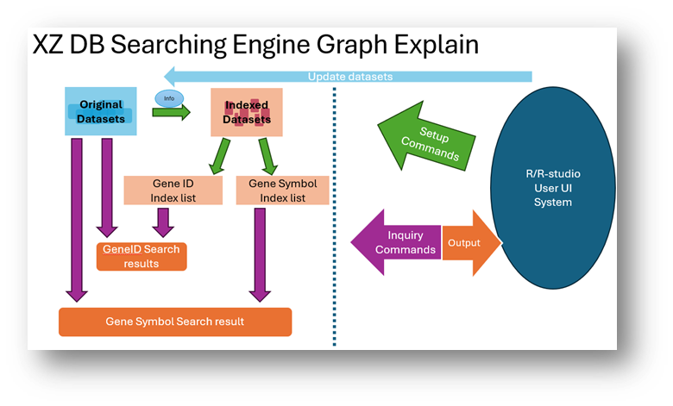

A. Auto Start

On Windows:
Install R and can be configured with a short cut on desktop:

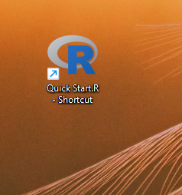

On Mac:
Make sure R is installed. Open the folder

Click MAC_Start.command
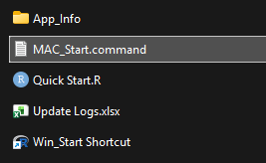

*If mac start is failed, can try backup inside App_Info.

B. Manually Start

Step 0. For return user:
Close all active R programs and Close R-Studio.

Step 1. Download / Open the folder:

Step 2. Open the “Quick Start.R” use R / R-Studio
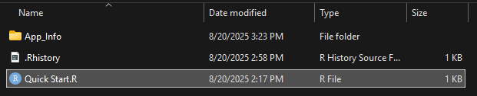

Step 3. Run the code (Only one line is enough)
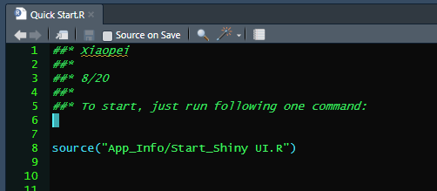

Start: Please wait for it to install necessary R packages on your computer if it’s missing.
NOW, you will see this window in browser:
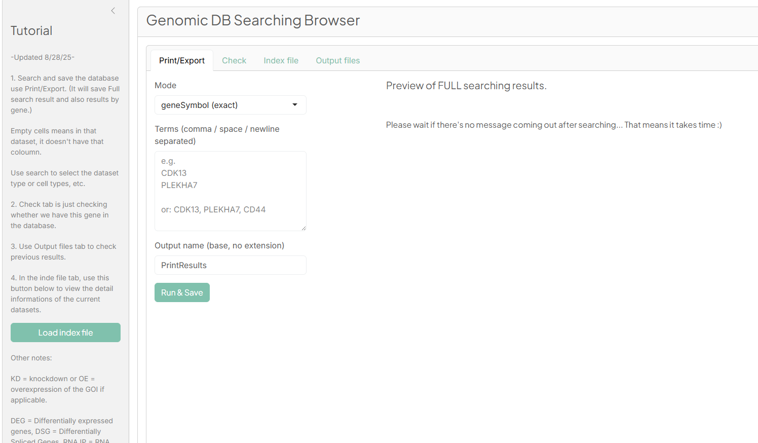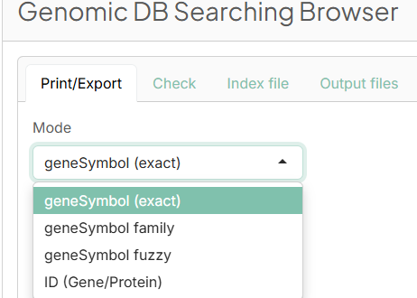

FUNCTIONS

Function 1. Go to ‘Print/Export’ to get detailed information
It have three different searching options for Gene Symbol (exactly/family/fuzzy), and one exactly match for protein ID and ENSEMBL gene ID.
For example, you want to search exactly CDK13 and NCBP2.
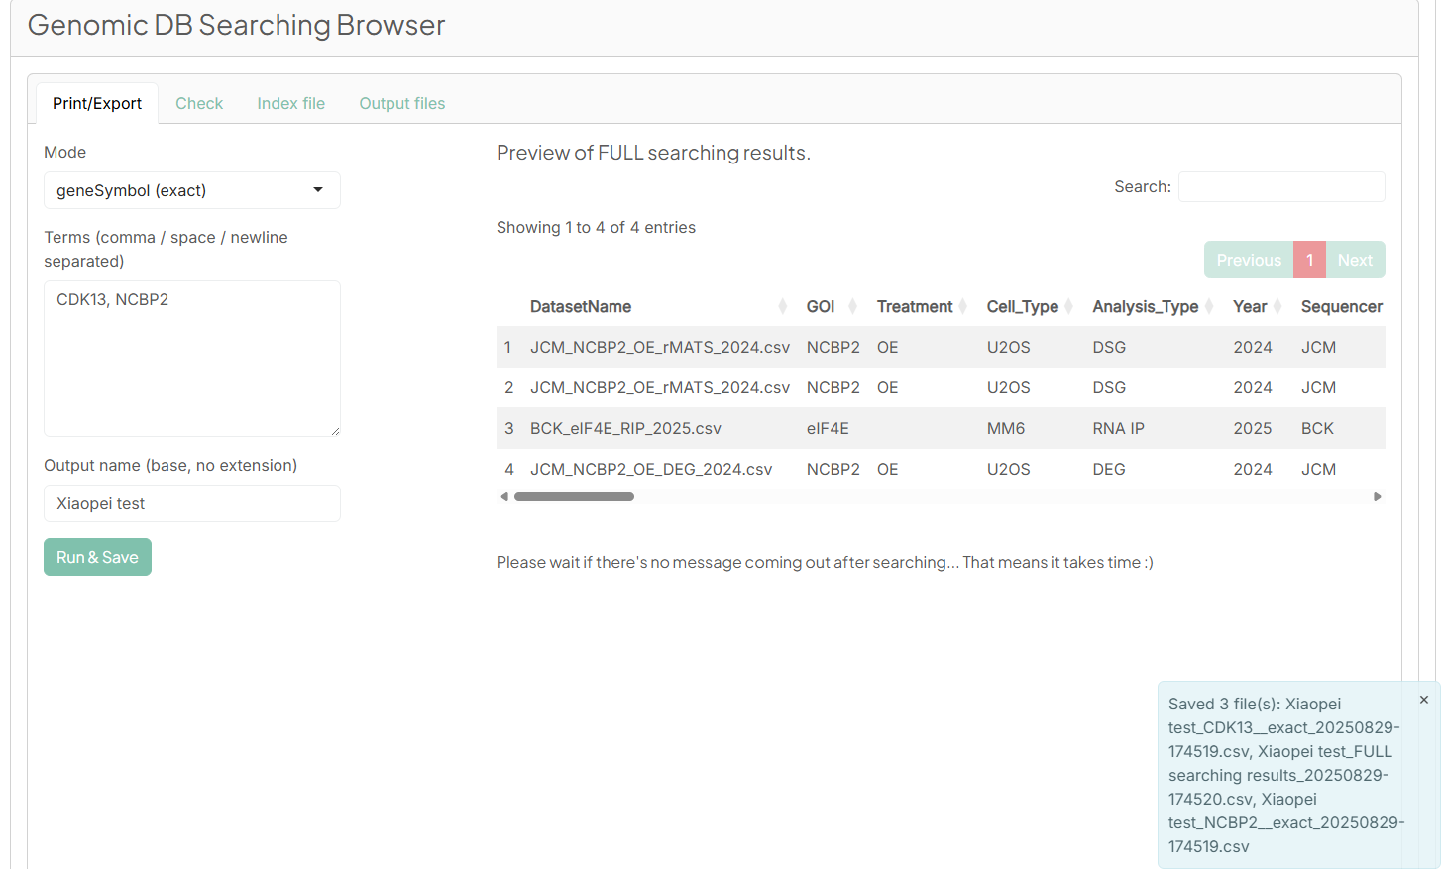
Full result is here, includes both of CDK13 and NCBP2 search result
Each line represents a row founded in our current database, with that database’s description at the beginning.
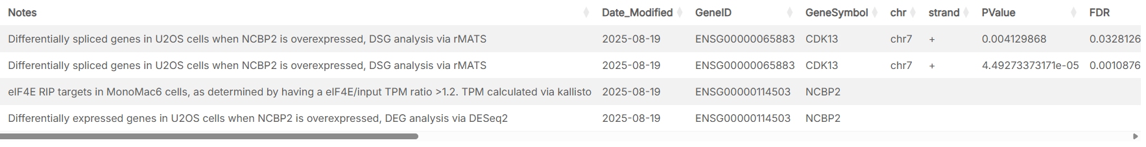
After search, It will save to 3 files: full results and details by 2 genes.
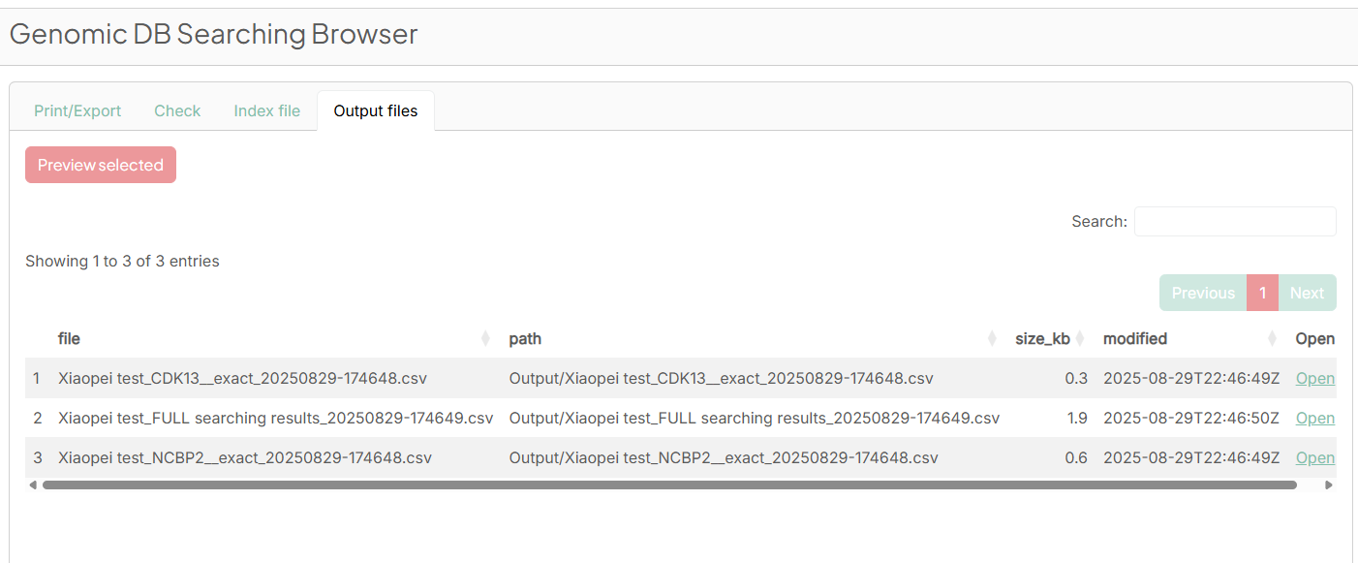

Function 2. Go to ‘Check’ to check which database a gene is in
check which database a gene is in or just look-up whether we have this gene.
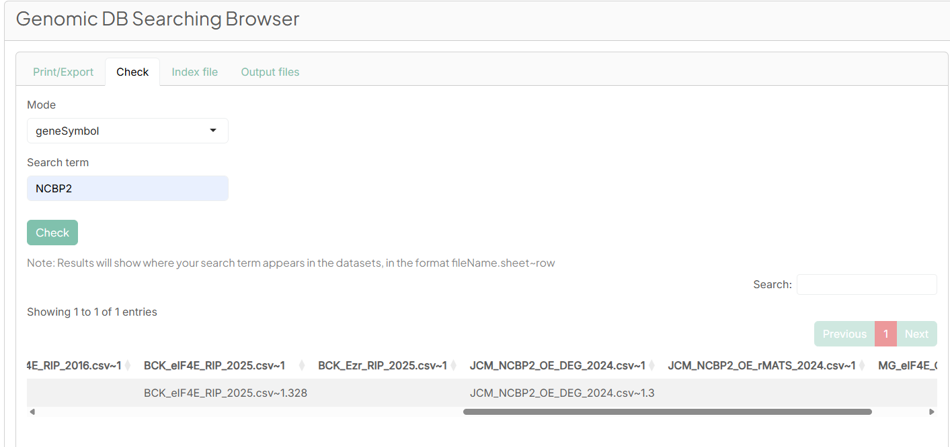

Function 3. Use left side “Load index file” button to see the data information.
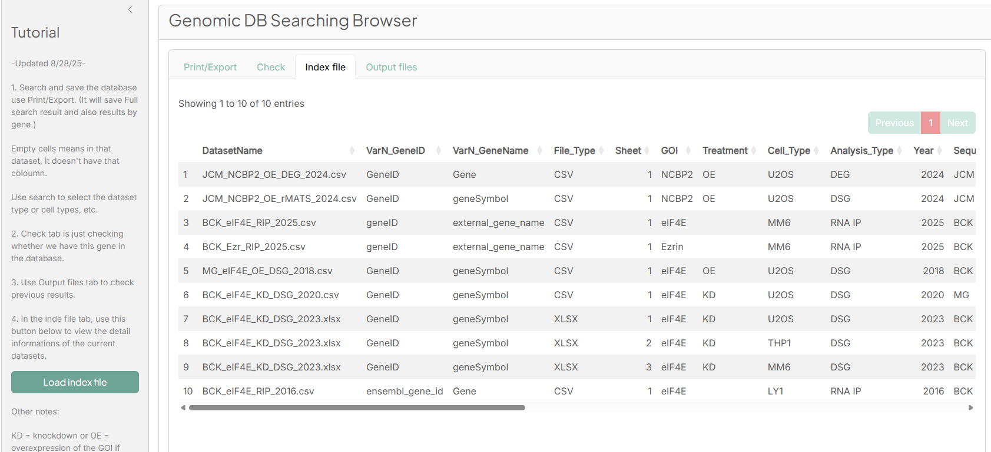

Function 4. Download or Preview your result in “Output files” tab
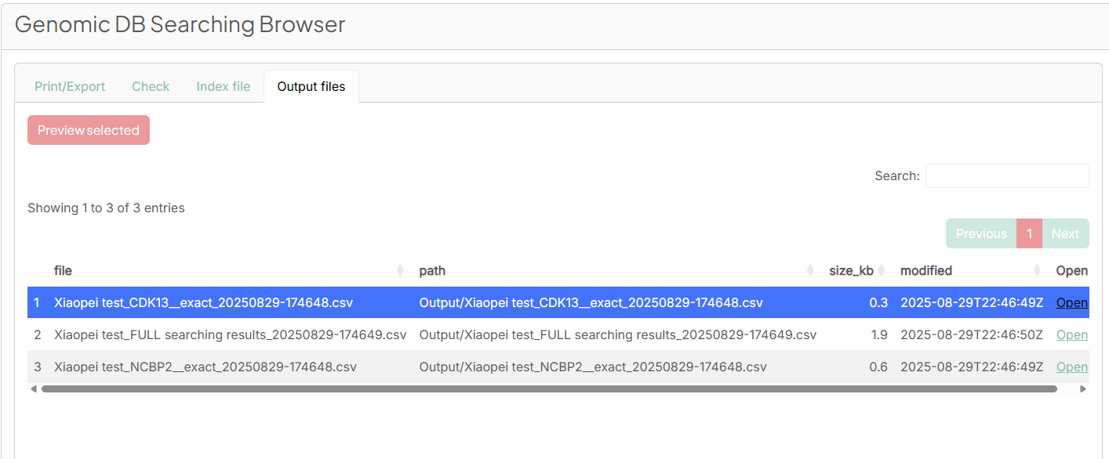
After select a result file, preview it using the red button on the top “preview selected”. (Not every output is good for preview.)
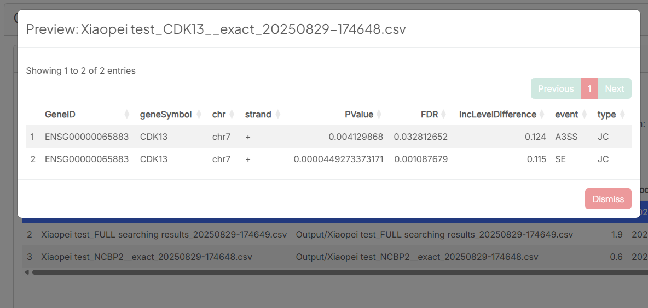
To download it, use the “open” button on the end of each row.
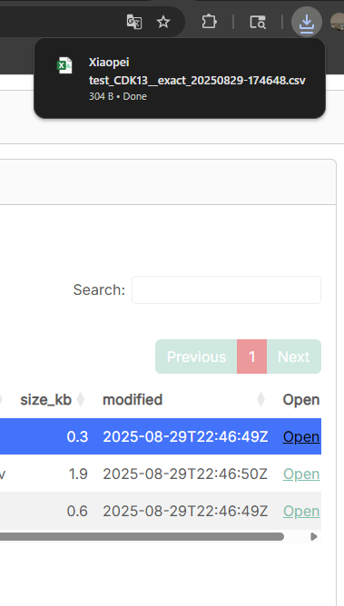
Usually, the output folder should be clean every month. So please save all the results you have done.

Function 5. Update Database
( FYI: If you don’t want to update the dataset index, just ignore the left side panel.)
After update datasets and Datasets infomation.xlsx under /App_Info folder, Run the following command:
- Build index (all)
- Build searching_GeneID.csv
- Build searching_geneSymbol.csv
Usually, the output folder should be clean every month.
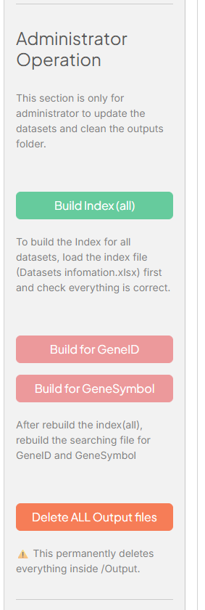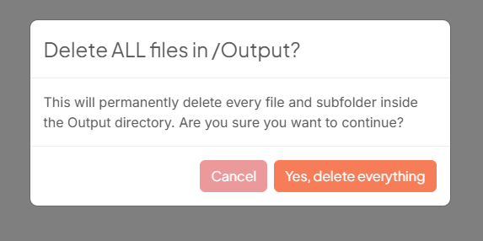

Function 6. Compare searched result with UniProt / MINT
UniProt is for search protein ID entry.
Mint use uniprotID to search protein interactions.
Requires internet access.

Last step
Close the browser tab and R/R-Studio/commander window after use.

Appendix
To configure short cut at windows computer:
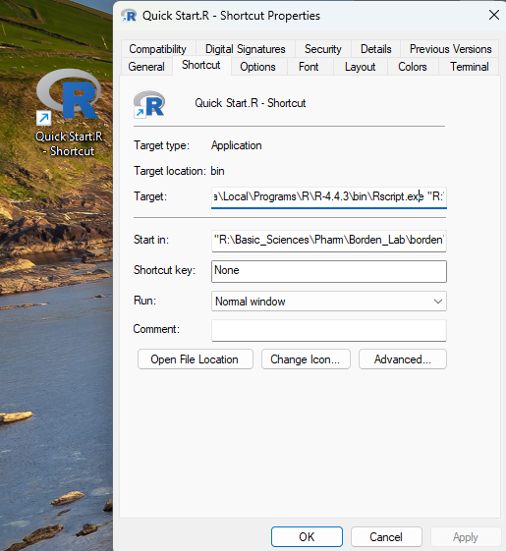

Edit target(start with your local R install location and end with path to “Quick Start.R”):
C:\Users\jcc1885\AppData\Local\Programs\R\R-4.4.3\bin\Rscript.exe "R:\Basic_Sciences\Pharm\Borden_Lab\borden\Database\Genomic result Browser\Quick Start.R"

To configure “One click start shortcut” at Mac computer:
Just make a text file named something.command at desktop
#!/bin/bash
….
In Terminal, run cd ~/Desktop
Also run chmod +x something.command

